

Arvind Pal

Arvind.pal@itcinfotech.com

ZEAS

ZEAS -Ingestion and Transformation Output Data

**ZEAS –Ingestion and Transformation Output Data**

|  |  |  |  |  |
| --- | --- | --- | --- | --- |
| Version | Date | Created by | Reviewed by | Changes |
| 1.0.0 | 8/12/2016 | Arvind Singh Pal |  |  |
|  |  |  |  |  |
|  |  |  |  |  |

Table of Contents

Introduction 2

Pre-requisites 3

Business Requirements 3

Existing functionality 3

Proposed functionality 3

Detailed functionality 3

Assumptions and Risks 6

# 

# Introduction

ZEAS is ETL tool which provide single platform for data lack, Ingestion and data transformation, it provides data connection which supports large range of data-sources formats such as

RDBMS – MYSQL, Oracle and DB2

Files - CSV, XLS, JSON, XML, Fixed width delimiter etc.

# Pre-requisites

ZEAS should be running in any one Hadoop distributed enlivenments (Apache Hadoop or HDP) with below Hadoop services-

* Hive
* Sqoop
* Oozie

# Business Requirements

User want to see output of his Ingestion and transformation, Allow him to check his Ingestion and Transformation output in local machine (client machine where Browser is getting open) and in server

Allow User to export output in any given server location as well.

# Existing functionality

ZEAS stores output in various ways Sqoop and map-reduce output in HDFS, same data will be available in Hive tables and Hive views.

# Proposed functionality

Give option to export and download Ingestion output in datasets and same option for transformation where each level of transformation cab be exported and download-

* Dataset output can be download (local, server) and exported to any other location.
* Data can be downloaded and exported in csv, json format with schema.
* Download and export Transformation output of each level

## Detailed functionality

1. Once Ingestion is success ,click on  “export or download”

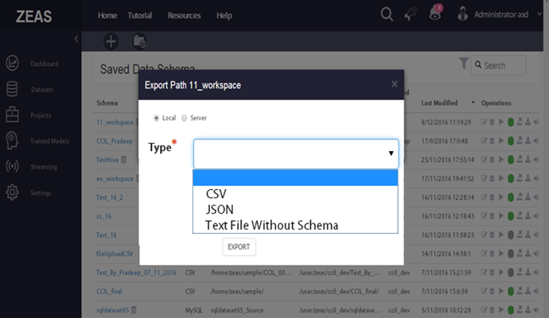

Screen -1 export from dataset

1. Export in Project “transformation”, allow this when transformation is manipulation (column filter, clean missing Data, Group By and Join) and Custom (Hive, pig and MapReduce).

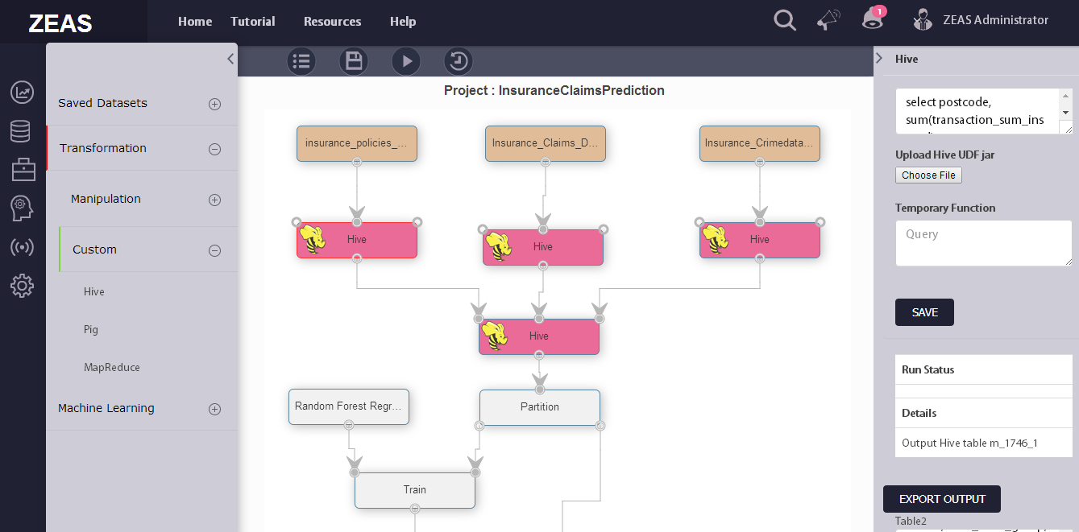

Screen-2 Export Output in Transformation

# Assumptions and Risks

1. Lack of dedicated resources.
2. No UI Developer
3. In case any requirement change the delivery time line will be impacted.